**Train a Deep Learning model**

**with AWS Deep Learning Containers on Amazon EC2**

AWS Deep Learning Containers (DL Containers) are Docker images pre-installed with deep learning frameworks to make it easy to deploy custom machine learning environments quickly by letting you skip the complicated process of building and optimizing your environments from scratch.

Using AWS DL Containers, developers and data scientists can quickly add machine learning to their containerized applications deployed on Amazon Elastic Container Service for Kubernetes (Amazon EKS), self-managed Kubernetes, Amazon Elastic Container Service (Amazon ECS), and Amazon EC2.

In this tutorial, you will train a TensorFlow machine learning model on an Amazon EC2 instance using the AWS Deep Learning Containers.

Initially set the permissions required to use the AWS Elastic Container services and then launching the Ec2 instance which can be accessed through command prompt I use Windows so I used Git bash for executing things.

Enabling permissions for the user to access Elastic Container module

Add the ECS Full Access Policy

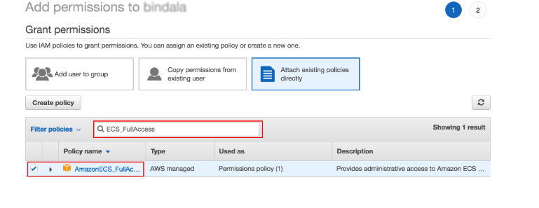

#### Launch an Amazon EC2 instance with Deep Learning Base AMI and required computing resources.

#### 

#### Running EC2 Instance

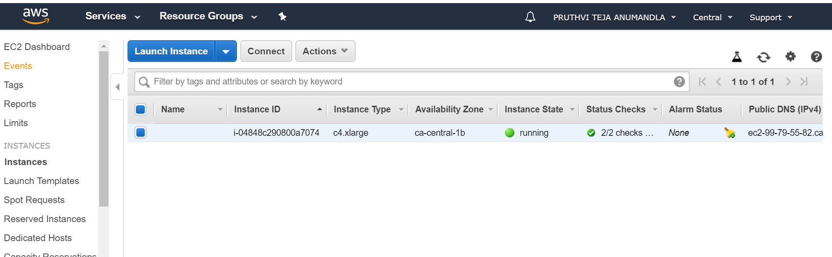

**Connecting EC2 Container instance using SSH used Git bash on Windows**

AWS Deep Learning Container images are hosted on Amazon Elastic Container Registry (ECR)

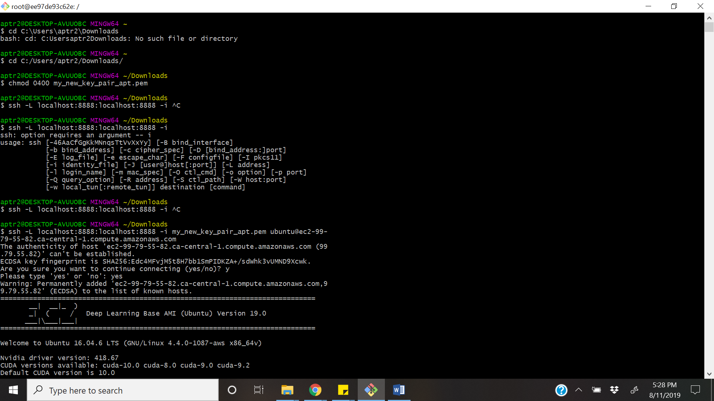

#### Configuring EC2 instance with AWS credentials Access ID and secret key

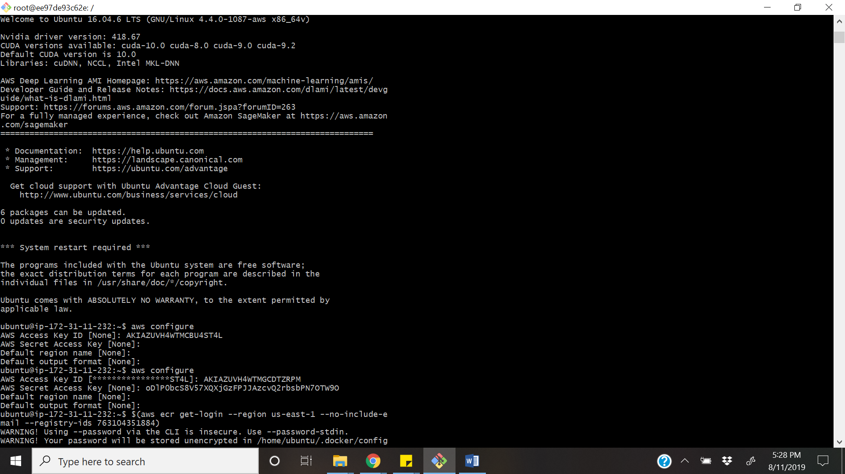

**Log in to Amazon ECR**

$(aws ecr get-login --region us-east-1 --no-include-email --registry-ids 763104351884)

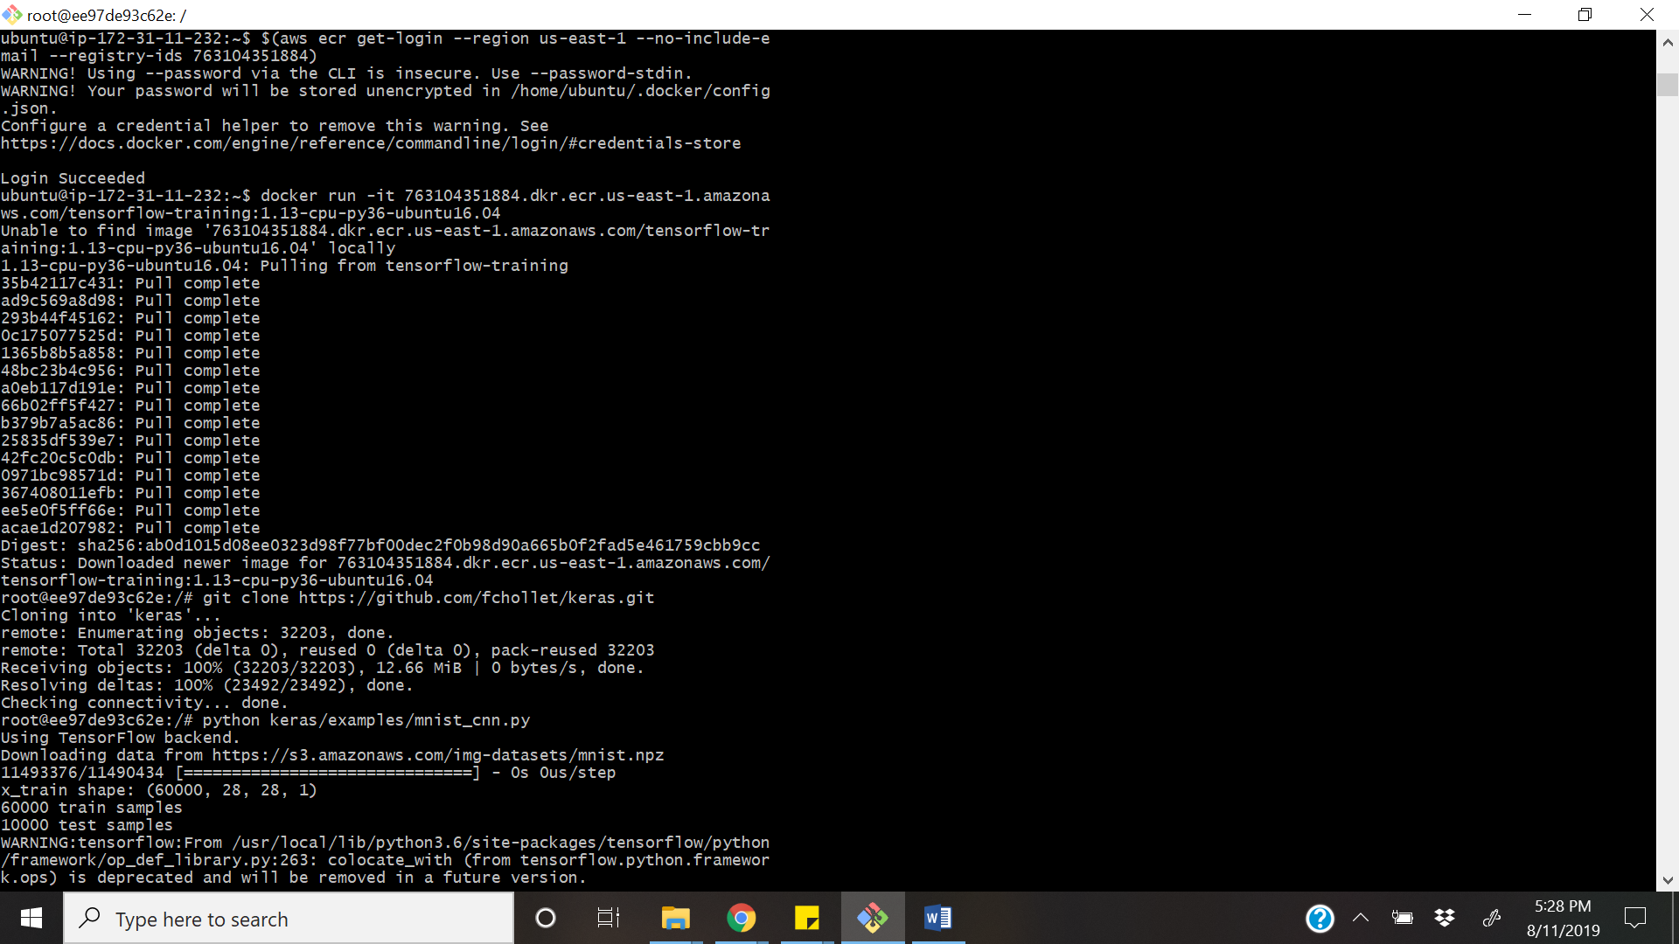

#### Run AWS Deep Learning Containers

#### docker run -it 763104351884.dkr.ecr.us-east-1.amazonaws.com/tensorflow-training:1.13-cpu-py36-ubuntu16.04

#### Pull an example model to train from github

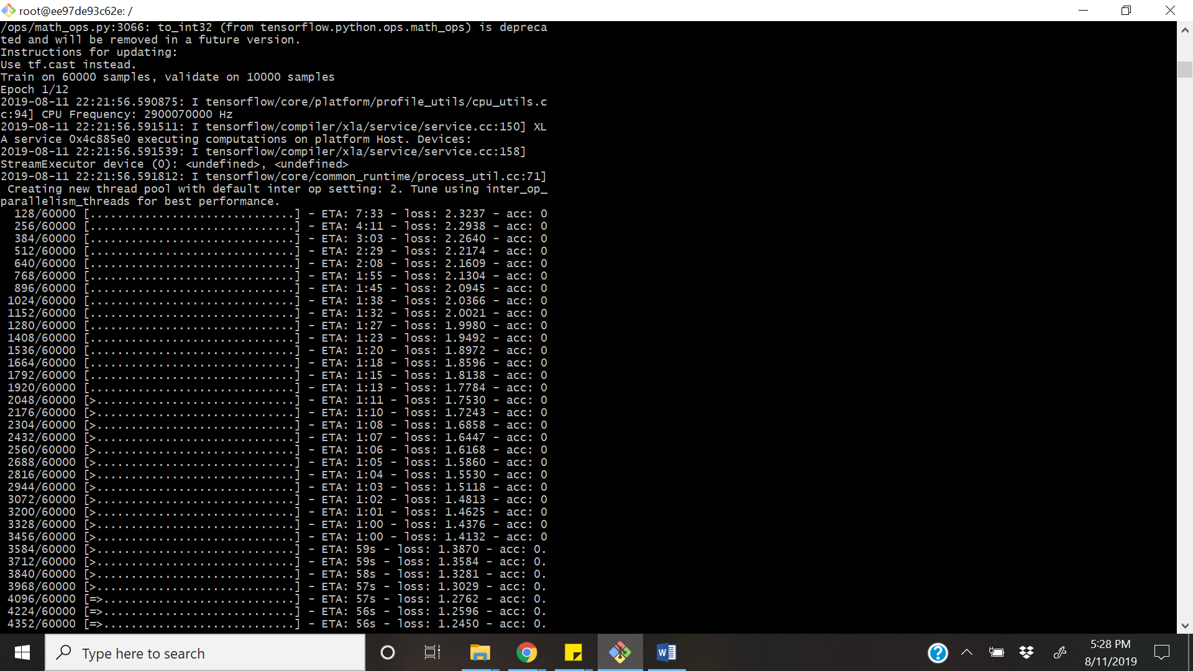

Final trained model and its accuracy

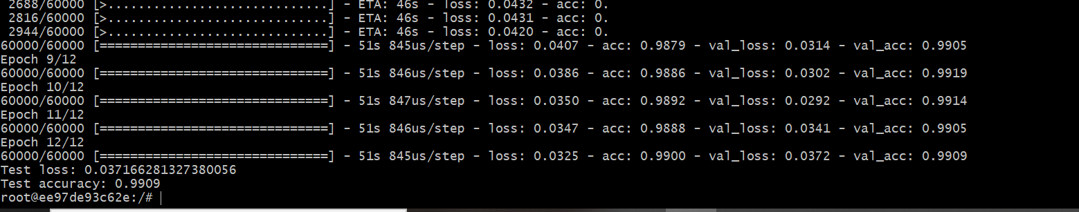

**Terminate your EC2 instance**

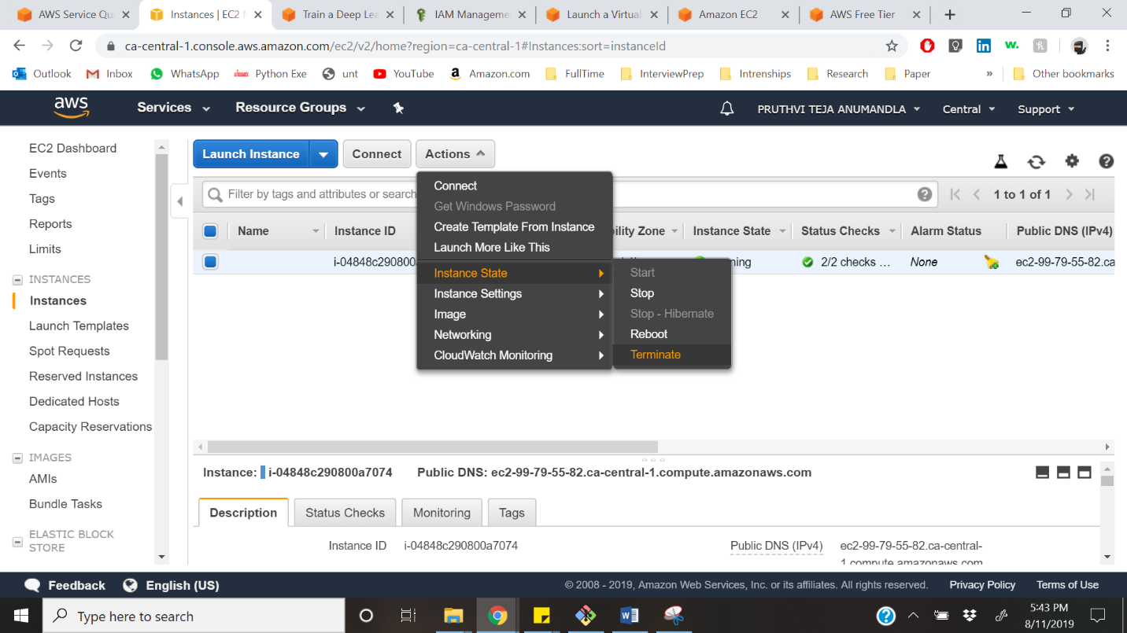

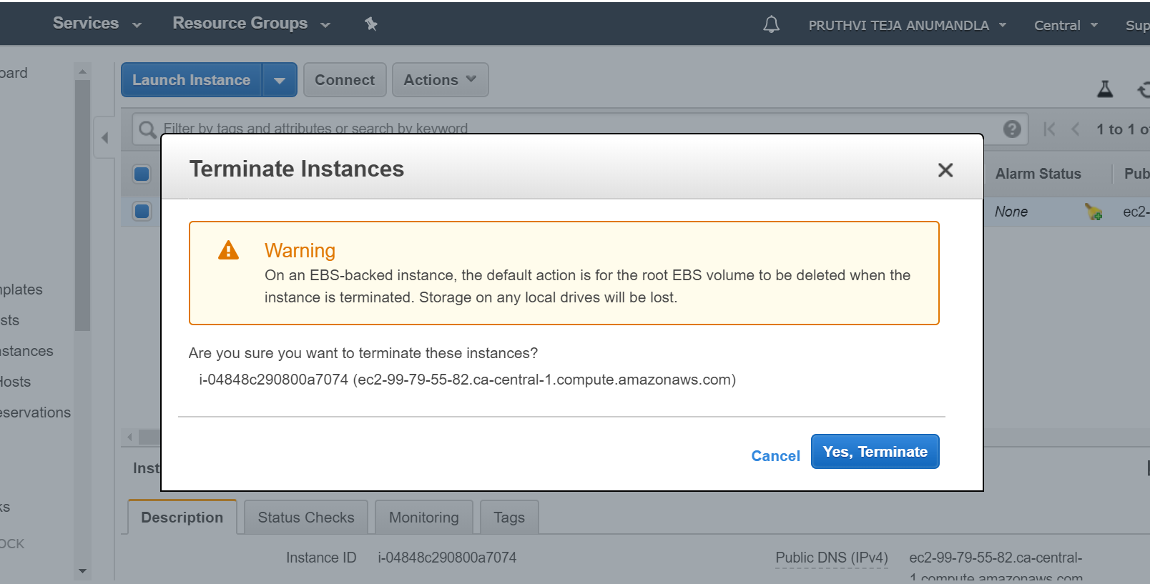



**Reference -** <https://aws.amazon.com/getting-started/tutorials/train-deep-learning-model-aws-ec2-containers/>